COS10029- Fundamentals of Programming
Name: Sovithyea Prach
Student ID: 105270743
Task 6.1
a/ float array_average (int array[], int array_size)
{
int i;
int temp1=0;
float temp2 = 0;
for (i=0; i< array_size; i++)
{
temp1 = temp1 + array[ i ];
}
return temp2 = (float)temp1/array_size;
}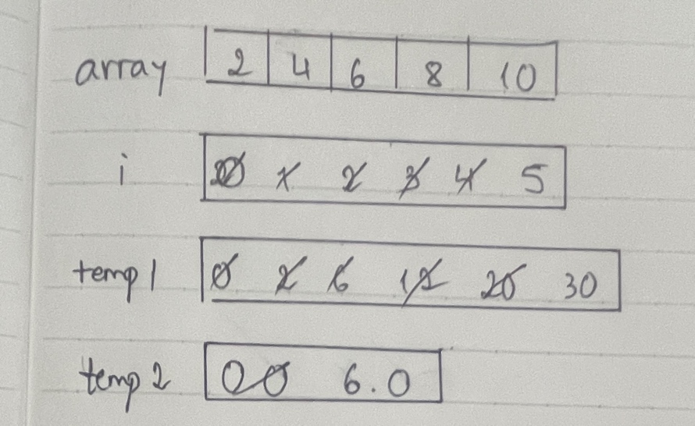
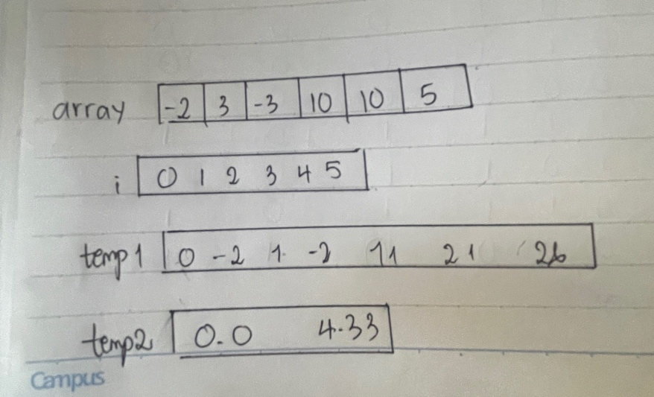

b/ int findSmallest (int array[], int array_size)
{
int i=0,temp1;
temp1=array[0];
for (i=1; i<array_size; i++)
{
if (array[i] < temp1)
temp1=array[i];
}
return temp1;
}
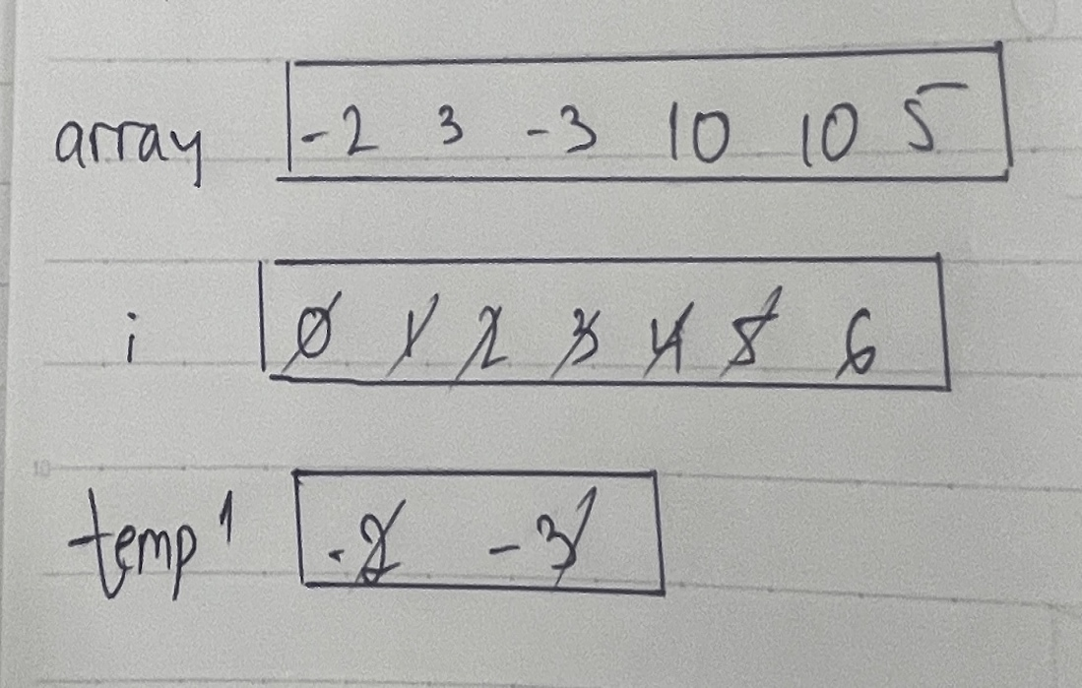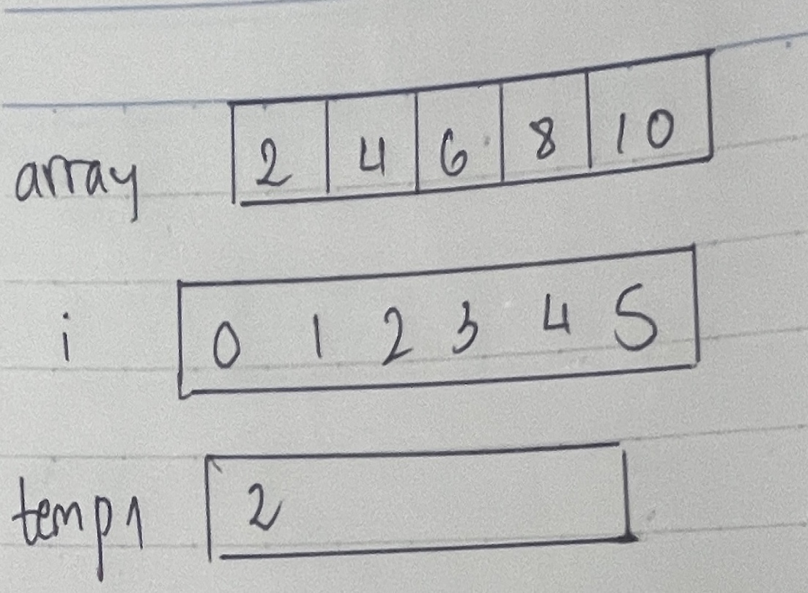
Task 6.2
Code:
#include <iostream>
using namespace std;
#define SIZE 10

int total_array(int data[], int size)
{
int total=0, i;

for(i=0; i<size; i++)
{
total = total + data[i];
}
return total;
}
bool check_total(int total)
{
if(total>100)
return true;
else
return false;
}
int negative_count(int data[], int size)
{
int neg=0, i;

for(i=0; i<size; i++)
{
if(data[i]<0)
{
neg++;
}
}
return neg;
}
int main()
{
int data_array[SIZE], i, key, total, neg;
cout<<"Enter values in the array:\n";

for(i=0; i<SIZE; i++)
{
cin >> data_array[i];
}
total = total_array(data_array, SIZE);
cout << "The total of the array is "<< total <<endl;

if (check_total(total))
{
cout << "The total is greater than 100\n";
}

else
{
cout << "The total is less than 100\n";
}
neg = negative_count(data_array, SIZE);
cout << "The array contains " << neg << " negative numbers" << endl;

return 0;
}

Output:
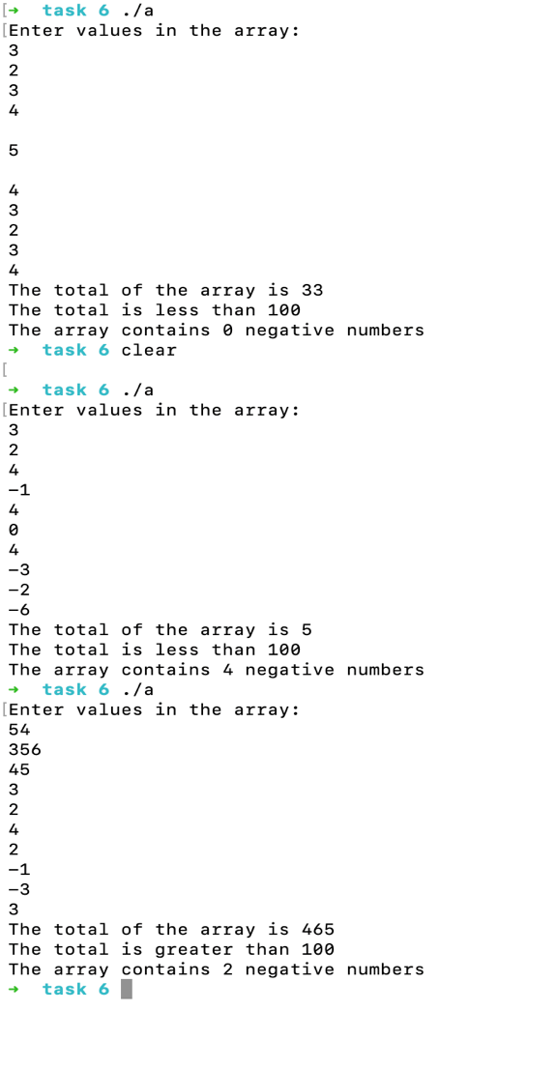
Task 6.3
#include "splashkit.h"
#include <ctime>
#define SIZE 1000

void fill_array(int data[])
{
int i;

for(i=0; i<SIZE; i++)
{
data[i]=rand()%700;
}
}

void draw_bar(int data[])
{
int i;
float x, y, rectwidth;
rectwidth=5;

for(i=0; i<SIZE; i++)
{
x= rectwidth*i;
y= screen_height() - data[i];
fill_rectangle(COLOR_RED, x, y, rectwidth, data[i]);
}
}

int main()
{
int data[SIZE];

open_window("Array Rectangle", 800, 600);
srand(time(NULL));
fill_array(data);

while(not quit_requested())
{
process_events();
clear_screen(COLOR_WHITE);
draw_bar(data);
refresh_screen();
}
}

Output:

